3. Write a Java program to print the area and perimeter of a circle.

Test Data:

Radius = 7.5

Expected Output

Perimeter is = 47.12388980384689

Area is = 176.71458676442586

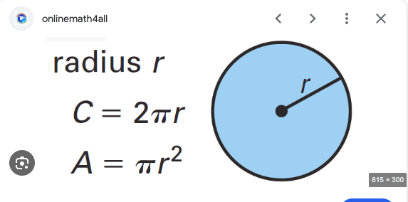

import java.util.Scanner;

public class Exercise3AreaOfCircle {

public static void main(String[] args) {

Scanner scnr = new Scanner(System.in);

System.out.println("Enter Radius");

double Radius = scnr.nextDouble();

System.out.println("Area of cirlce is"+" "+ Math.PI\*Radius\*Radius);

System.out.println("Perimeter of circle is"+" "+ Math.PI\*2\*Radius);

}

}